ITW1
UNIX PROJECT
Pacha Venkata Sri Harsha
20075063
4 Year B. Tech
Computer Science and Engineering
pacha.venkatasharsha.cse20@itbhu.ac.in

Here the files are:
myhelp.sh
help.sh
file.sh
text.sh
status.sh

NOVOICE MODE

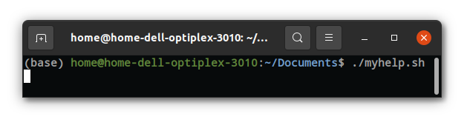

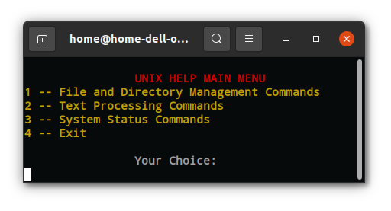

Running as Novoice Mode, see there are no arguments passed.

Entering into sub menu of File and Directory Management.
(Enter 1)

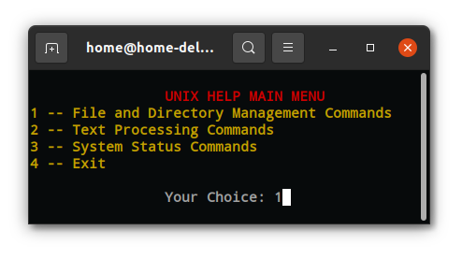

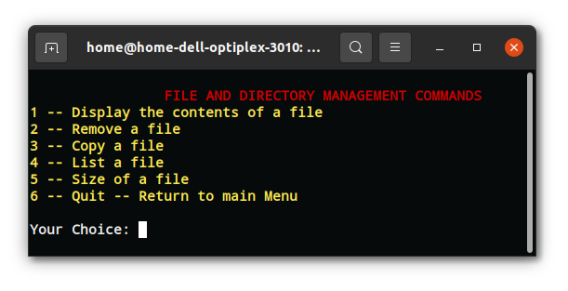
1. File and Directory Management Commamds

- Display the contents of a file
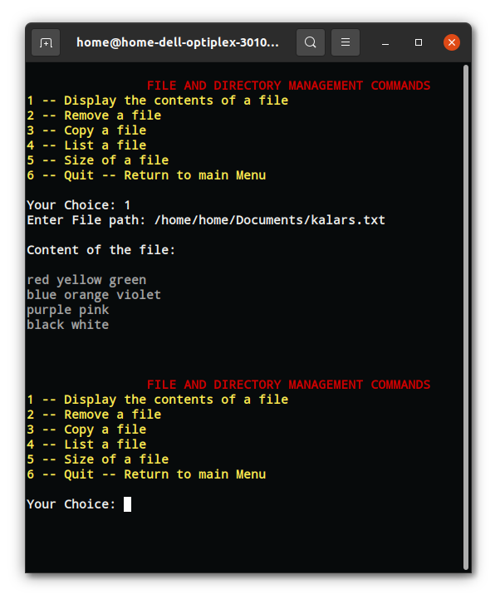

- Remove a file

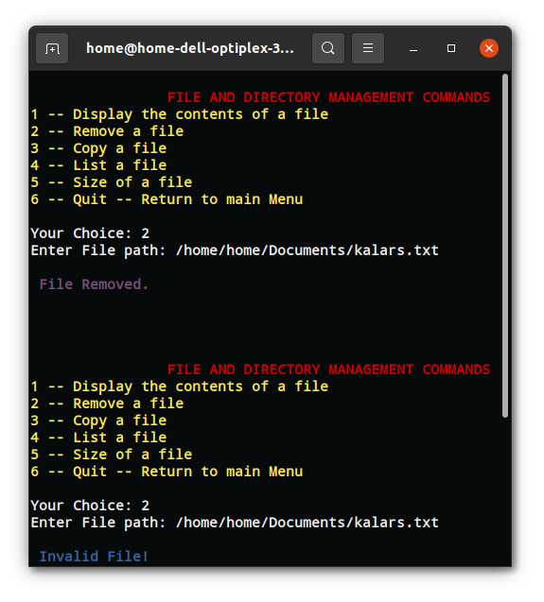

- Copy a file
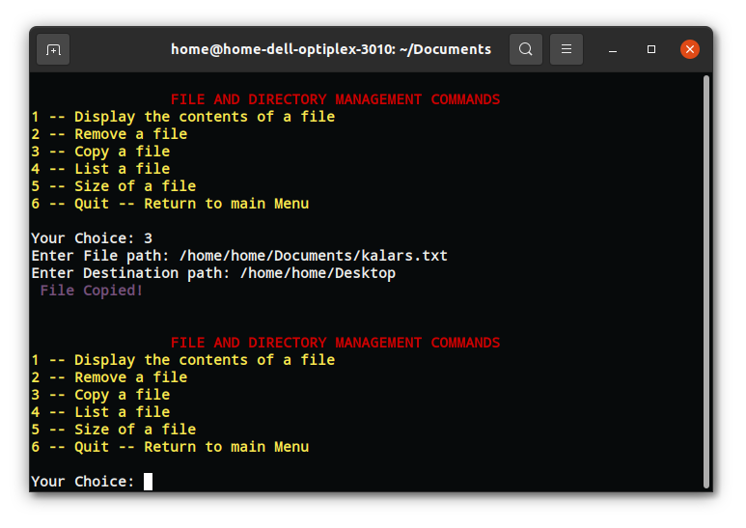
- List a file
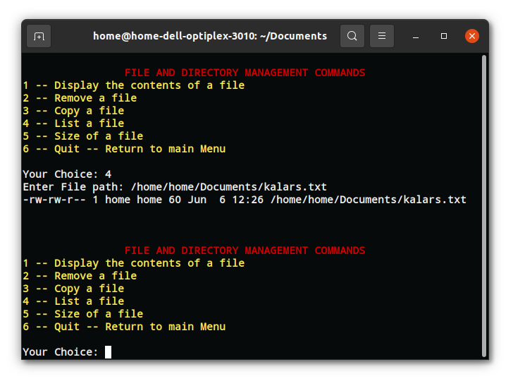

- Size of a file
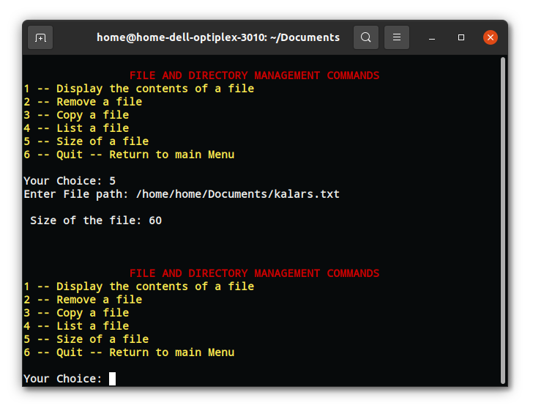
2. Text Processing Commands
Entering into submenu of Text Processing Commands.
(Enter 2)

- Search a file for a pattern
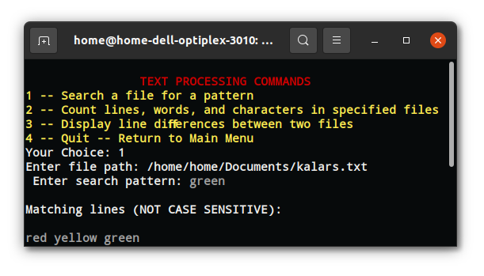
- Count lines, words, and characters in specified files
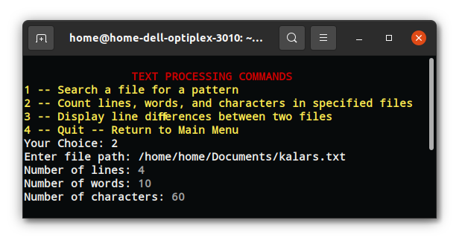

- Display line diﬀerences between two files

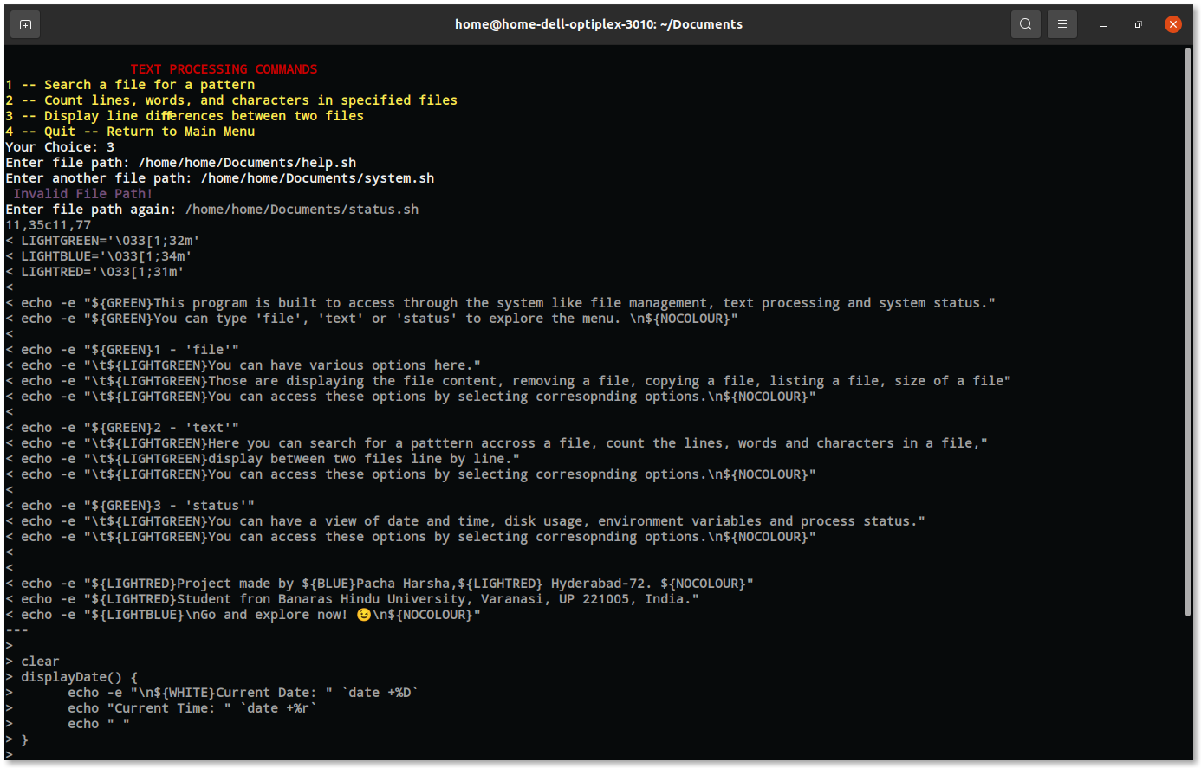

3. The‌ ‌System‌ ‌Status‌ ‌Commands‌ ‌Sub-menu
Enter 3 in main menu.

- Display the current date and time
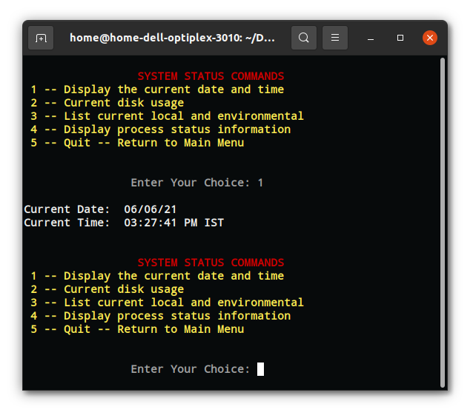

- Current disk usage
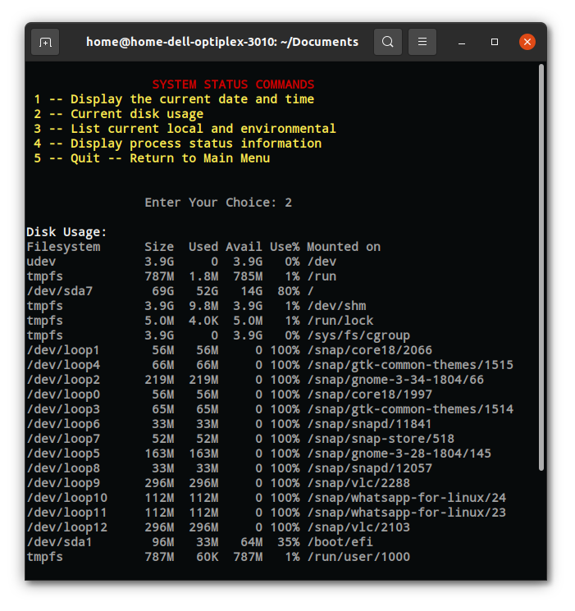

- List current local and environmental
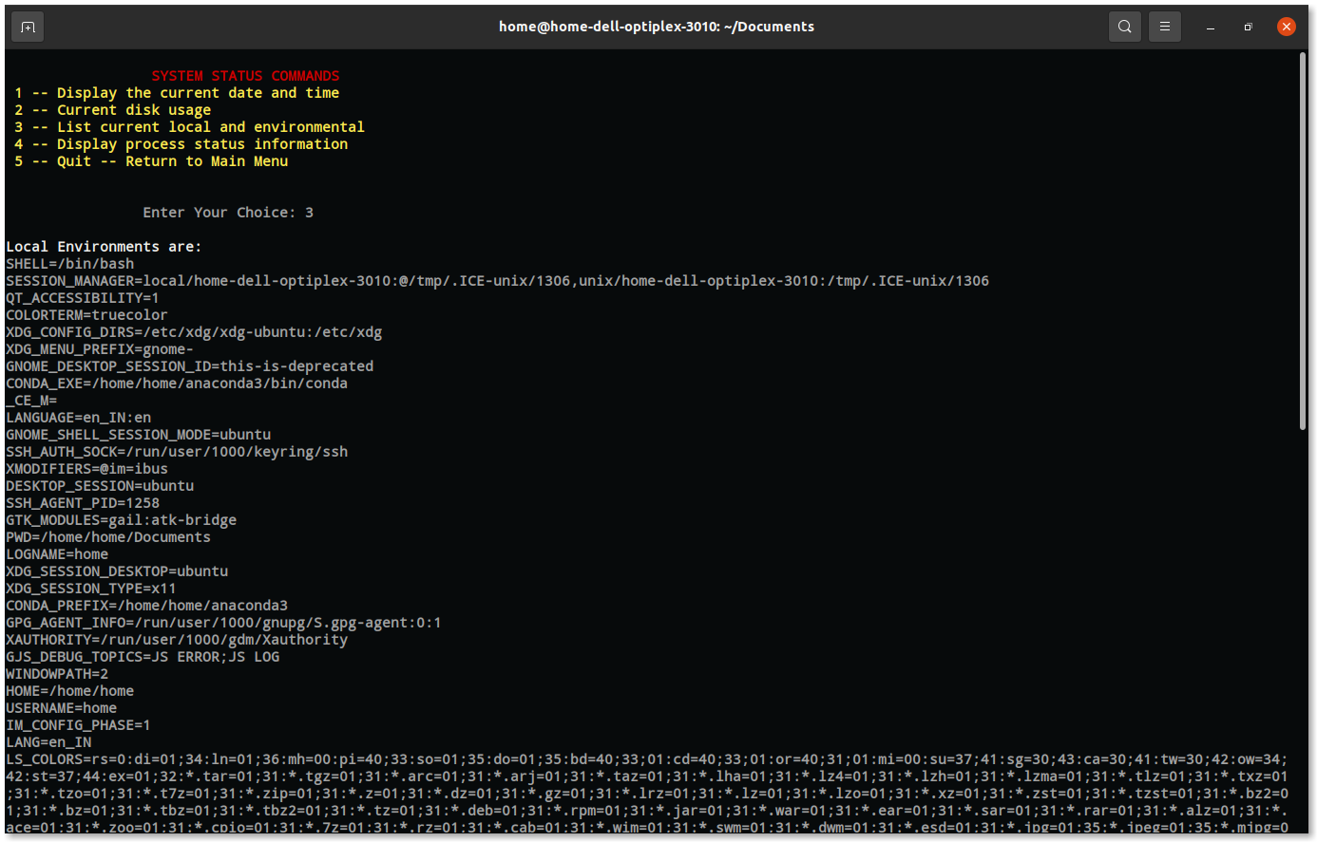
- Display process status information
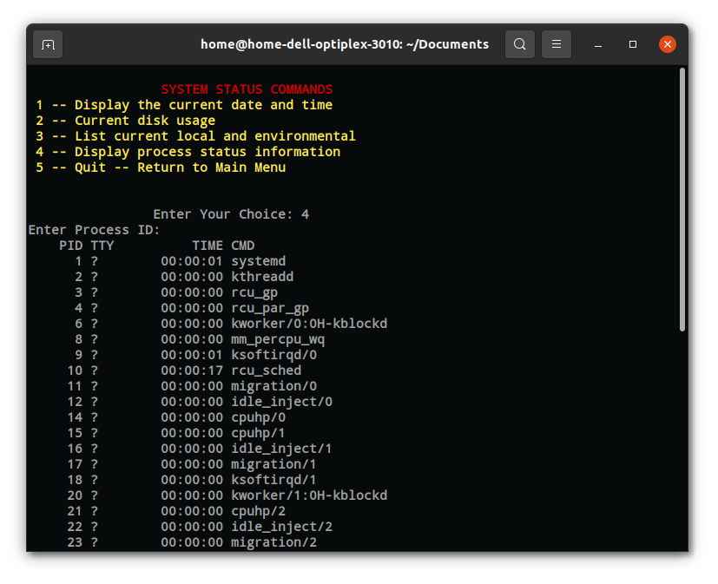

EXPERT MODE

Now pass an argument ‘help’ to open the help text.

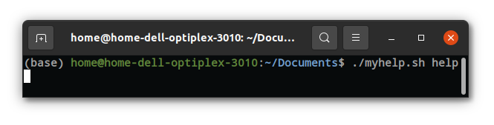
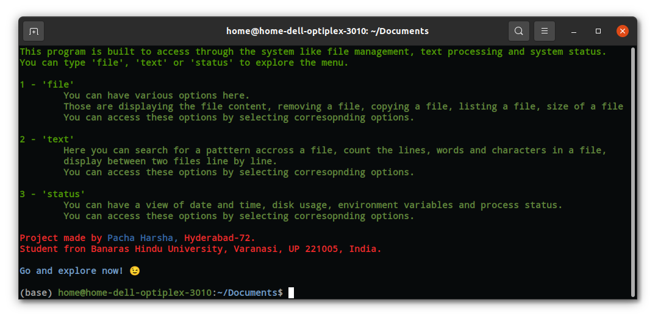
To open File and Directory Management Commamds, pass an argument ‘file’ .
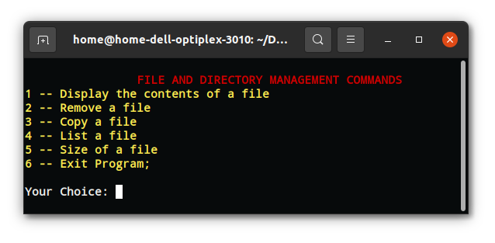
A menu like this will open up.
1. File and Directory Management Commamds

- Display the contents of a file
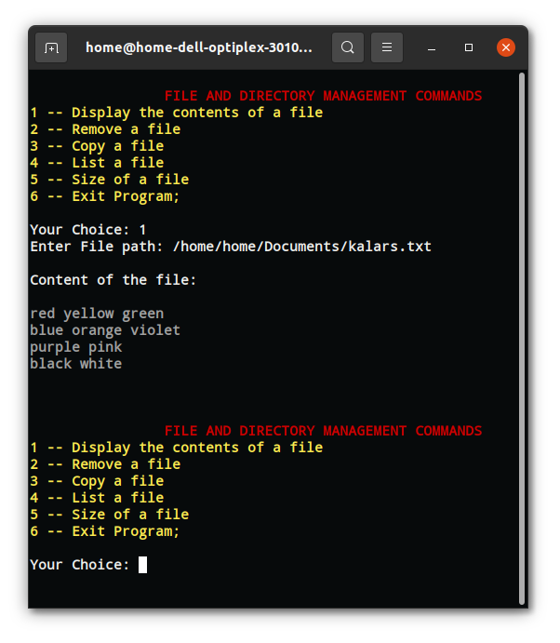

- Remove a file
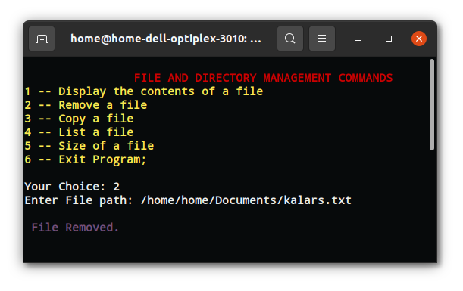
- Copy a file
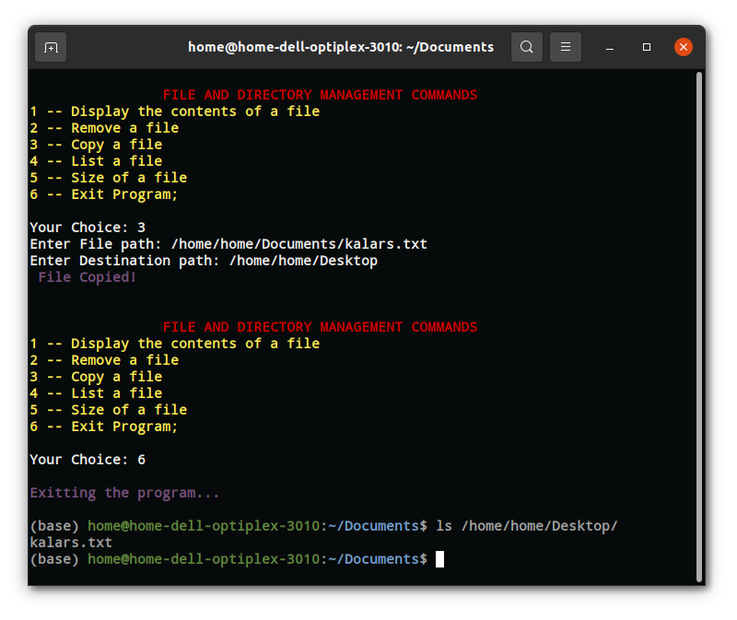
- List a file
let’s list all bash files

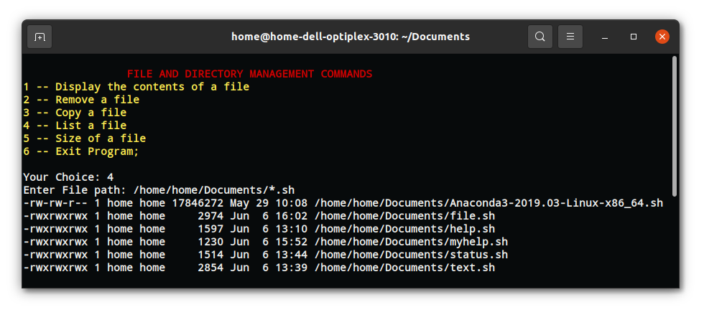
- Size of a file
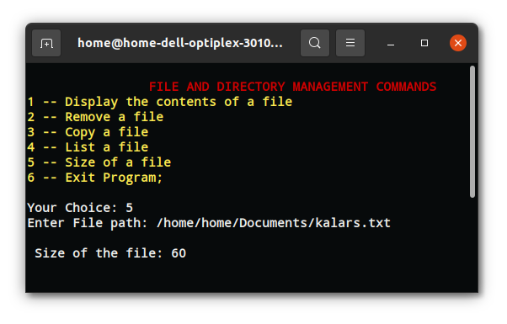
2. Text Processing Commands

To open Text Processing Commands sub menu, pass argument namely ‘text’.
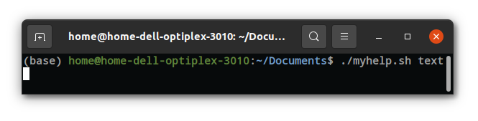

- Search a file for a pattern
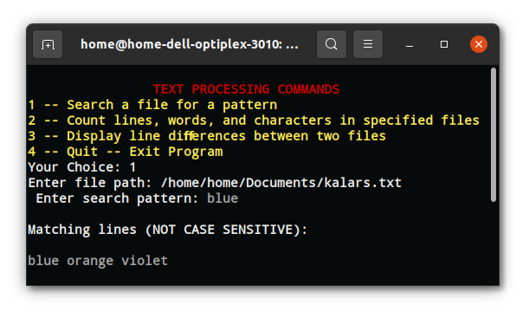

- Count lines, words, and characters in specified files
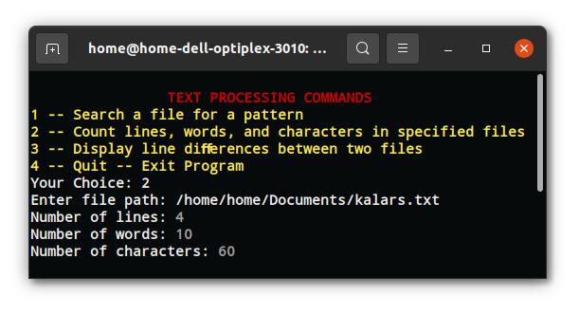
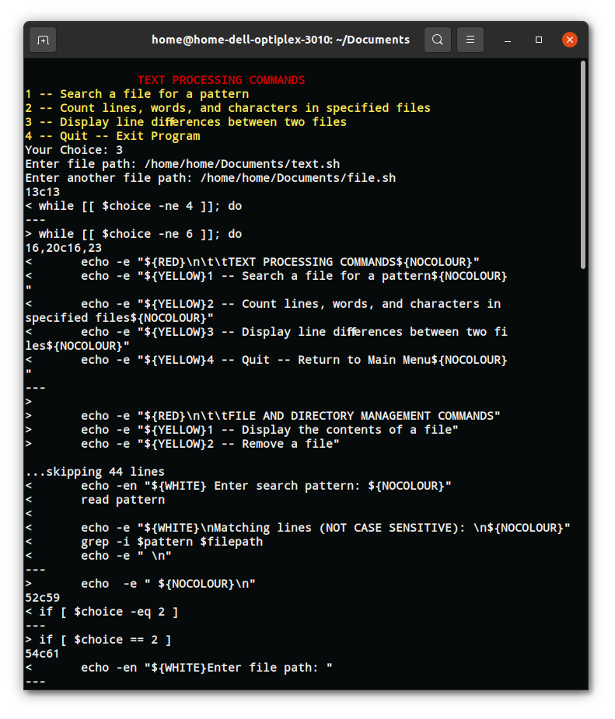
- Display line diﬀerences between two files

3. The‌ ‌System‌ ‌Status‌ ‌Commands‌ ‌Sub-menu
For this you will have to pass the argument ‘status’.
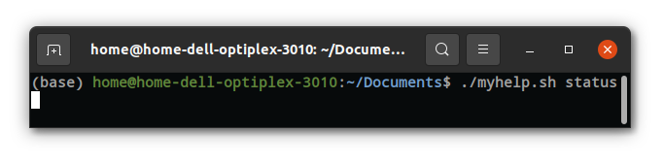
- Display the current date and time
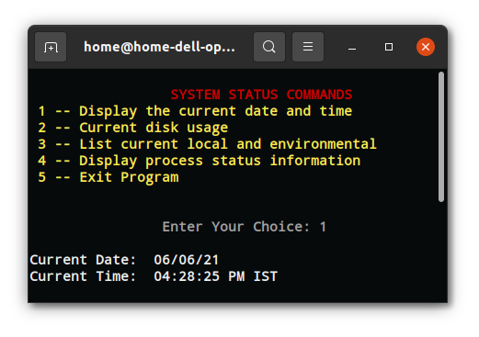

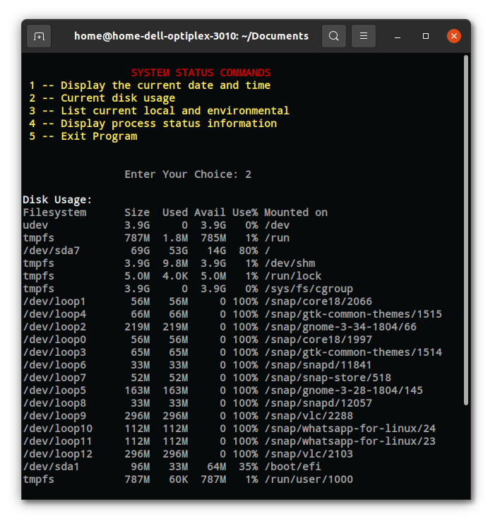
- Current disk usage

- List current local and environmental
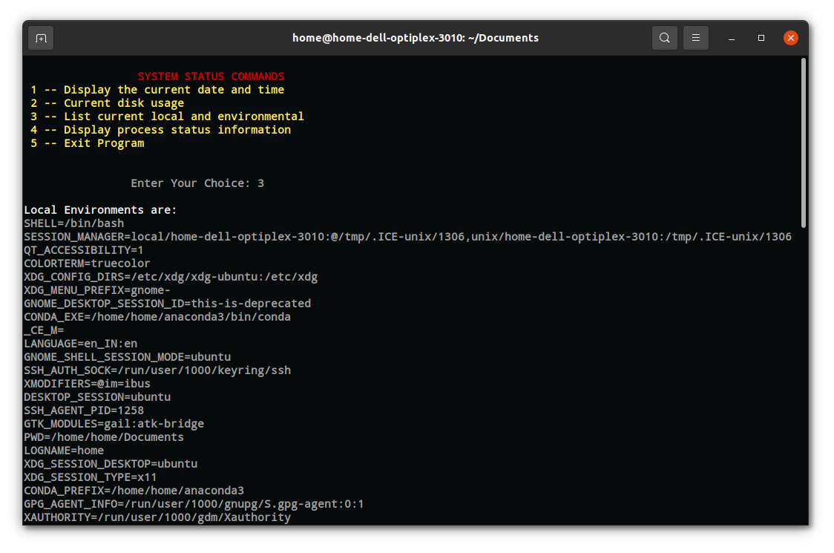
- Display process status information
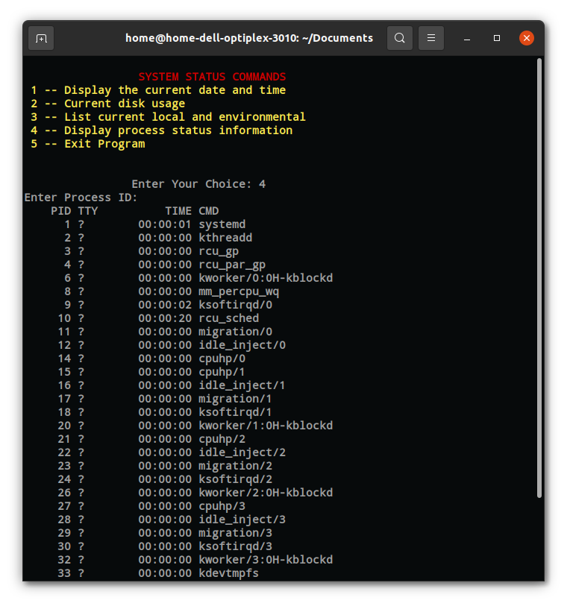

Exitting the program in EXPERT MODE
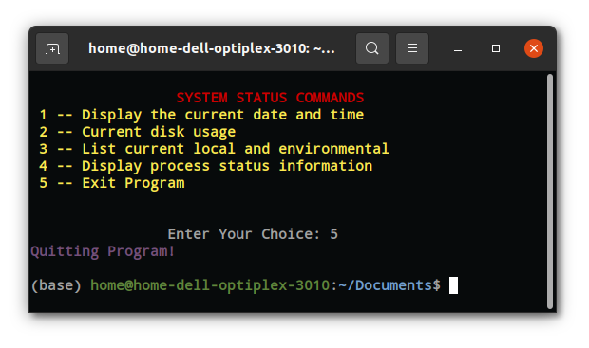

Exitting the program in NOVOICE MODE
